Assignment 3 Report

Darien Morrison 3380082

COP4610

Below are the screenshots of the results of the thread program without synchronization. Without synchronization, the threads increment the same shared variable, however their final value differs because the threads are not waiting on the other threads to finish before updating the final value.

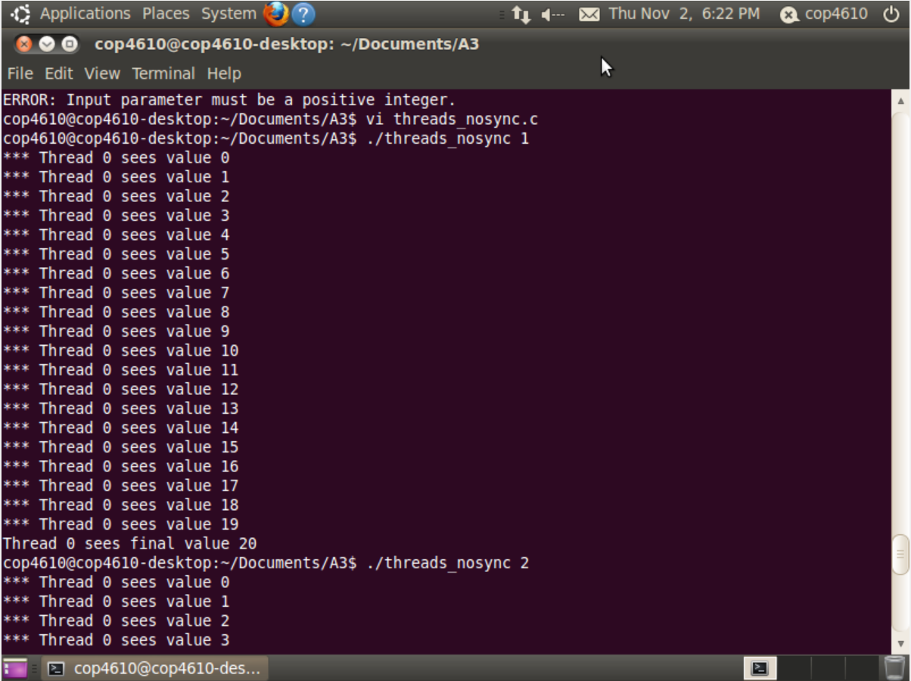

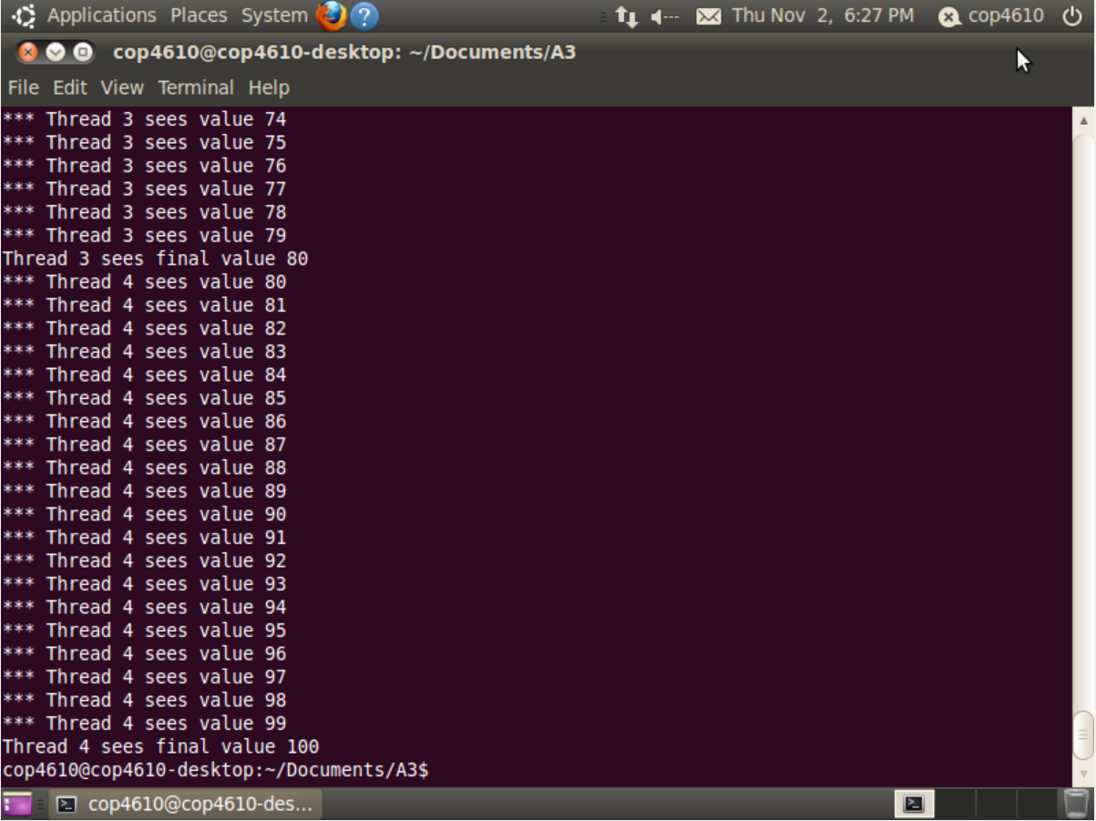

Below are the results of the screenshots of the results of the thread program with synchronization. The threads increment the same shared variable and their final value ends up being the same because the threads wait for each other to finish before updating their final value.

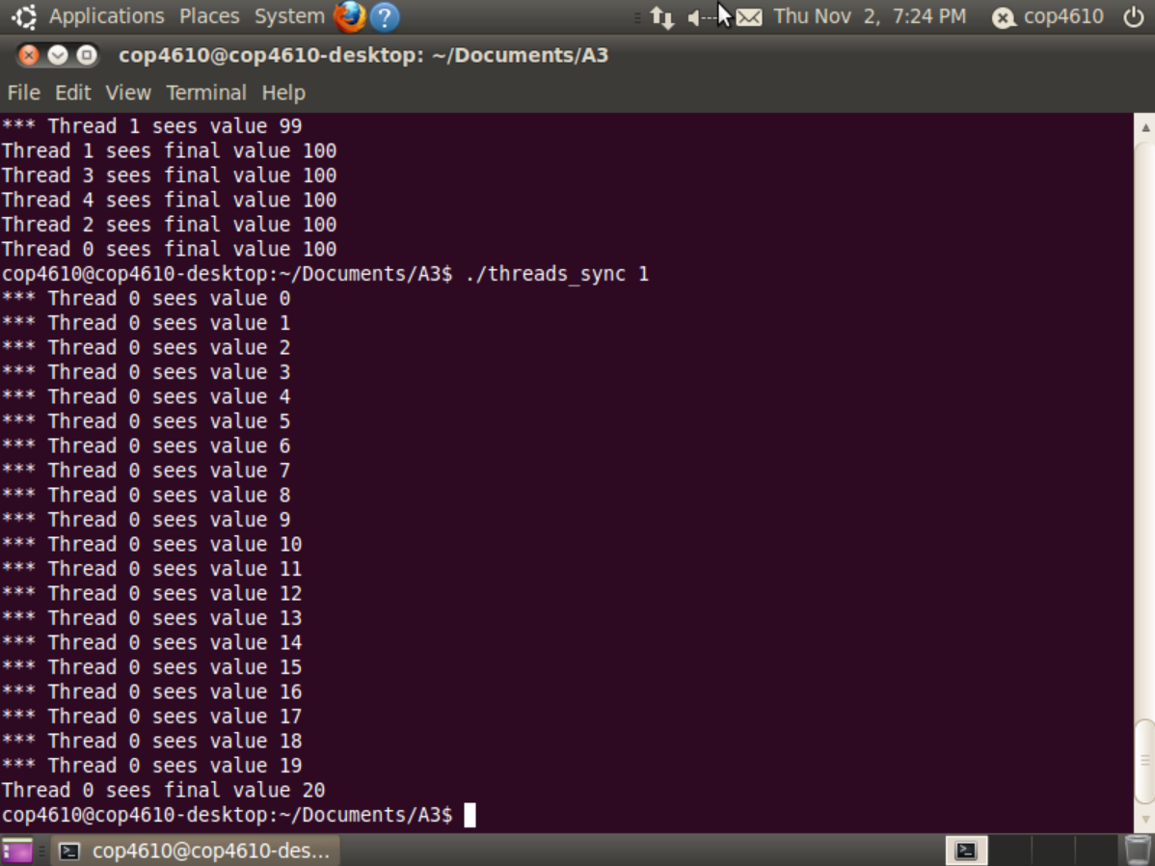

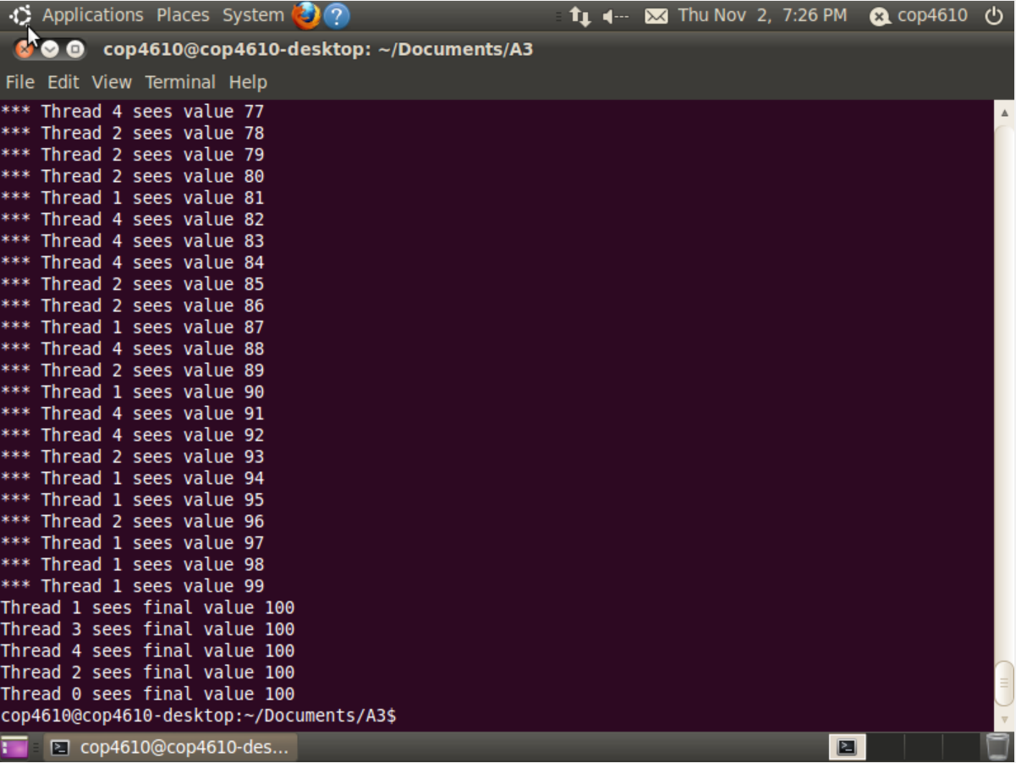

Below is the output of dmesg:

